/

WEB TECHNOLOGY
CSPE505
ASSIGNMENT - I

NAME : MOHAMED AKRAM
ROLL NO : 2236090011
CLASS : BE CSE V SEM
DATE : 16-08-2023

Create a Web-Page Using Various Tags

HTML CODE:

<!DOCTYPE html>
<html lang="en">
<head>
<meta charset="UTF-8">
<meta name="viewport" content="width=device-width, initial-scale=1.0">
<title>My Website</title>
<style>
body {
font-family: Arial, sans-serif;
line-height: 1.6;
margin: 0;
padding: 0;
background-color: #f5f5f5;
}
header {
background-color: #4285f4;
color: #ffffff;
text-align: center;
padding: 10px 0;
}
main {
max-width: 800px;
margin: 20px auto;
padding: 20px;
background-color: #ffffff;
border-radius: 5px;
box-shadow: 0 2px 4px rgba(0, 0, 0, 0.1);
}
h1, h2, h3, h4, h5, h6 {
color: #333333;
margin: 10px 0;
}
p {
margin: 10px 0;
}
strong, b {
font-weight: bold;
}
i {
font-style: italic;
}
em {
font-style: italic;
}
ul {
margin: 10px 0;
padding-left: 20px;
}
table {
border-collapse: collapse;
width: 100%;
margin-bottom: 20px;
}
th, td {
border: 1px solid #dddddd;
text-align: left;
padding: 8px;
}
th {
background-color: #f2f2f2;
}
form {
margin-top: 20px;
}
label {
font-weight: bold;
}
input, select, textarea {
width: calc(100% - 10px);
padding: 10px;
margin-bottom: 10px;
border: 1px solid #ccc;
border-radius: 3px;
}
button {
background-color: #4285f4;
color: #ffffff;
padding: 10px 20px;
border: none;
border-radius: 3px;
cursor: pointer;
}
button:hover {
background-color: #357ae8;
}
a{
text-decoration: none;
font-weight: 900;
}
.intro {
background-image: url('background.jpg');
background-size: cover;
background-position: center;
color: #ffffff;
text-align: center;
padding: 80px 0;
}

.intro h1 {
font-size: 2.5rem;
margin-bottom: 20px;
}

.projects {
background-color: #f9f9f9;
padding: 40px 0;
text-align: center;
}

.project-link {
display: inline-block;
margin: 10px;
padding: 10px 20px;
background-color: #4285f4;
color: #ffffff;
border-radius: 3px;
text-decoration: none;
font-weight: bold;
}
footer{
text-align: center;
}
</style>
</head>
<body>
<header>
<h1>Welcome to My Website</h1>
</header>
<main>
<h2>About Me</h2>
<p>Hello,I'm Mohamed Akram. I am a web enthusiast interested in learning and sharing web technologies. <em>HTML</em>, <strong>CSS</strong>, and <code>JavaScript</code> are my favorite tools.</p>
<h2>Skills</h2>
<ul>
<li>Web Design</li>
<li>Frontend Development</li>
<li>Responsive Layouts</li>
<li>UI/UX Design</li>
</ul>
<h2>Latest Projects</h2>
<table>
<thead>
<tr>
<th>Project</th>
<th>Description</th>
</tr>
</thead>
<tbody>
<tr>
<td>Portfolio Website</td>
<td>A personal portfolio showcasing my skills and projects.</td>
</tr>
<tr>
<td>Sign Up Form</td>
<td>A sign-up form showcases proficiency in HTML, CSS, responsive design, and attention to detail.</td>
</tr>
<tr>
<td>Where's Wally</td>
<td>A simple game showcases my skill to integrate backend scoring for leaderboard</td>
</tr>
</tbody>
</table>

<div class="projects">
<h2>Check Out My Latest Projects</h2>
<p>These projects showcase my skills and creativity.</p>
<div class="project-links">
<a class="project-link" href="https://dark-wizz.github.io/portfolio/" target="_blank">Portfolio</a>
<a class="project-link" href="https://dark-wizz.github.io/sign-up_form/" target="_blank">Sign Up Form</a>
<a class="project-link" href="https://dark-wizz.github.io/wheres-wally/" target="_blank">Where's Wally</a>
</div>
</div>

<h2>Contact Me</h2>
<form>
<label for="name">Name:</label>
<input type="text" id="name" name="name" placeholder="Enter your name" required>
<label for="email">Email:</label>
<input type="email" id="email" name="email" placeholder="Enter your email" required>
<label for="message">Message:</label>
<textarea id="message" name="message" rows="4" placeholder="Enter your message" required></textarea>
<fieldset>
<legend>Additional Information</legend>
<label for="age">Age:</label>
<input type="number" id="age" name="age" min="18" max="99">
<label for="gender">Gender:</label>
<select id="gender" name="gender">
<option value="male">Male</option>
<option value="female">Female</option>
<option value="other">Other</option>
</select>
</fieldset>
<button type="submit">Send Message</button>
</form>
</main>
<footer>
<p>© 2023 MyWebsite. All rights reserved.</p>
</footer>
</body>
</html>

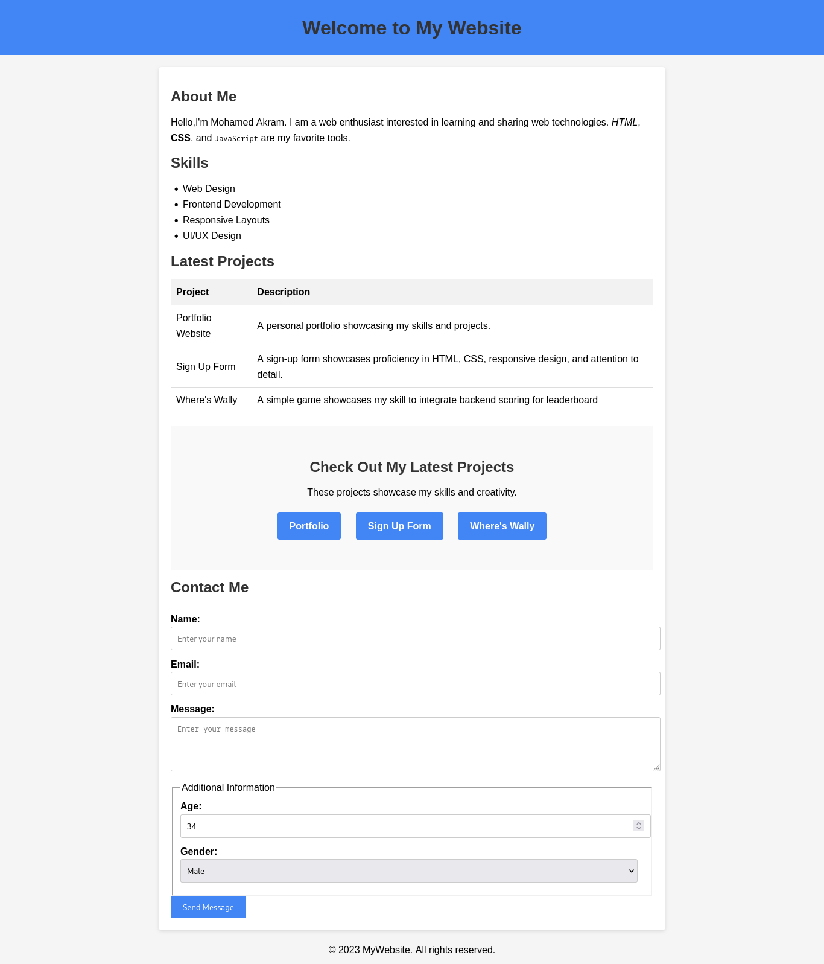
PREVIEW:

Tags Used:

<!DOCTYPE html>
<html />
<head />
<meta />
<title />
<style />
<body />
<header />
<h1 />
<main />
<h2 />
<p />
<em />
<strong />
<code />
<ul />
<li />
<table />
<thead />
<tr />
<th />
<tbody />
<tr />
<td />
<form />
<label />
<input />
<textarea />
<button />

